Election speech

None!

He did no effort at all on the conference to win the election, he knows however alot of people and only confinced them to vote for him via ht-mail or via a federation conference

He was the national coach and U20 coach some seasens ago, I’m not sure which seasens but defenitly he was not the previous U20 coach, so I cant get information out of those matches

forum

No information so far

Experience

4-3-3: | solid |  | 4-5-1: | poor
3-5-2: | weak |  | 5-3-2: | weak
3-4-3: | solid |  | 5-4-1: | poor

Team Spirit: composed
Confidence: decent

Next games

30-9-2005 (World Cup):
U-20 Nippon - U-20 Nigeria
7-10-2005 (World Cup):
U-20 België - U-20 Nippon
14-10-2005
Free
21-10-2005 (World Cup):
U-20 Panama - U-20 Nippon

Last games

09/23/2005 (National Friendly): U-20 España - U-20 Nippon 0 - 4

Midfield
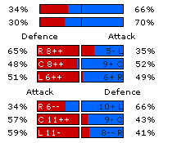

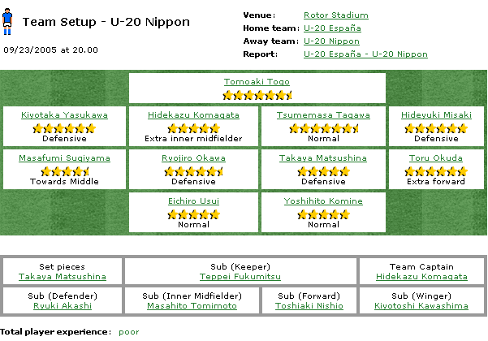

My view

They only got solid experience on 3-4-3 and 4-3-3, I see no use why he should play 4-3-3 versus us because 3 Nippon defenders will give them better ratings yet then our attack so why waste another spot on a defender, in that case only 3-4-3 rests with experience. Since their last succes versus Spain (mostly 19 year old played for Spain) I see the chance very big that he will also prefere a 3-4-3 versus us. On the other side their next match is away versus Belgium, which will be very diffucult for them so they can optain to level up their experience on the formation they want to play versus Belgium (3-5-2 ? or will they take the rist of playing 3-4-3 vs Belgium).
Their squad

Ryuki Akashi
10 070, 20 years, excellent form
Has wretched experience and poor leadership abilities
Belonging to VästeråsGurkan FF

Teppei Fukumitsu
49 500, 20 years, passable form
Has wretched experience and poor leadership abilities
Belonging to C.F. Organyà

Joji Horigoshi
12 930, 20 years, solid form
Has poor experience and weak leadership abilities [Quick]
Belonging to FC Thad

Kiyotoshi Kawashima
12 210, 19 years, passable form
Has poor experience and poor leadership abilities
Belonging to Azdaje

Hisayuki Kitajima
15 050, 20 years, solid form
Has poor experience and weak leadership abilities [Technical]
Belonging to FC Manel

Hidekazu Komagata 1
22 450, 20 years, solid form
Has weak experience and solid leadership abilities
Belonging to F.T.C.V.G.

Yoshihito Komine
23 340, 20 years, passable form
Has poor experience and wretched leadership abilities
Belonging to fc universal

Yoson Masudu
410, 35 years, inadequate form
Has outstanding experience and solid leadership abilities
Belonging to Shirayuri Sky

Takaya Matsushina
21 950, 20 years, solid form
Has wretched experience and weak leadership abilities
Belonging to Bolton Bullets

Hideyuki Misaki
20 500, 20 years, solid form
Has wretched experience and inadequate leadership abilities
Belonging to IPSWICH FC

Tateo Nakasawa
16 830, 20 years, solid form
Has wretched experience and wretched leadership abilities [Head]
Belonging to FC Knuffe

Toshiaki Nishio
17 720, 19 years, solid form
Has poor experience and wretched leadership abilities [Powerful]
Belonging to Yasporbi 05 Sentolo

Hayuma Okanao
13 960, 19 years, weak form
Has wretched experience and weak leadership abilities
Belonging to Los Tinos

Ryojiro Okawa
23 840, 20 years, solid form
Has poor experience and weak leadership abilities
Belonging to FC Toth

Toru Okuda
27 860, 20 years, excellent form
Has weak experience and wretched leadership abilities
Belonging to Blu Dreamers

Hisamitsu Shibata
18 600, 20 years, solid form
Has poor experience and passable leadership abilities
Belonging to FC BATORY

Hiroyasu Shirasu
10 610, 19 years, solid form
Has poor experience and weak leadership abilities [Quick]
Belonging to Non-fur

Masafumi Sugiyama
23 570, 20 years, solid form
Has weak experience and passable leadership abilities
Belonging to Dynamo Dablice

Tsumemasa Tagawa
21 190, 20 years, excellent form
Has poor experience and weak leadership abilities [Powerful]
Belonging to Yakuza

Tomoaki Togo
43 800, 19 years, inadequate form
Has poor experience and inadequate leadership abilities
Belonging to Sukebe Girls

Masahito Tomimoto
15 950, 20 years, weak form
Has weak experience and passable leadership abilities [Quick]
Belonging to Columbus Cardinals

Tatsuhito Uboshita
11 950, 19 years, inadequate form
Has wretched experience and wretched leadership abilities [Head]
Belonging to FC Zenit_SPb

Eichiro Usui
23 560, 20 years, inadequate form
Has poor experience and passable leadership abilities [Unpredictable]
Belonging to Grampus Eight

Kiyotaka Yasukawa
16 400, 20 years, solid form
Has poor experience and passable leadership abilities [Head]
Belonging to Häme Predators

